Math 1Name______________________________

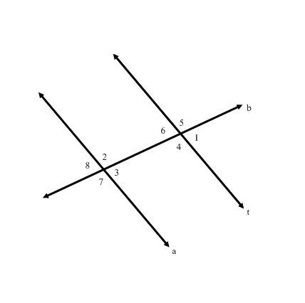**6-2 Parallel Lines with Algebra 2** Date___________

* *I can define and apply important geometric terms.*

**Use the diagram and the given conditions for each set of problems.**

For Numbers 1-7, If , find the following measures.

1. 
2. 
3. 
4. 
5. 
6. 
7. 

**Given: **

For Numbers 8- 11, If  and , find the following measures. **(SHOW ALL WORK)**

1. *x* = ______ 9.  10.  11. 

For Numbers 12-15, If  and , find the following measures. **(SHOW ALL WORK)**

1. *x* = ______ 13.  14.  15. 

For Numbers 16-19, If  and , find the following measures. **(SHOW ALL WORK)**

1. *x* = ______ 17.  18.  19. 

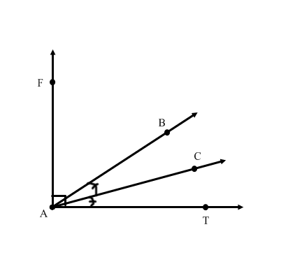Use the diagram below for Numbers 20-25, If  and .

20. Find x

21. 

22. 

23. =

24. =

25. 